The Atomic Rube

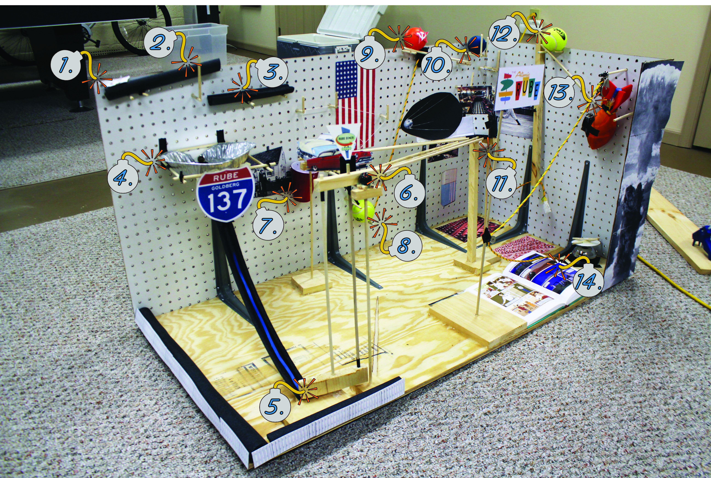

1. A magnet lifts another magnet from the left side of a platform, which rotates clockwise due to the weight of a marble on the right side.
2. The rotated platform causes the marble to roll onto a second platform.
3. The second platform rotates counterclockwise due to the weight of the marble
4. The marble falls into a pie tin funnel and through a chute, striking a rotating barrier at the bottom.
5. The rotating barrier causes a second barrier attached above it to rotate away from a marble, which starts to roll.
6. The marble rolls down a ramp and into a cup attached to a small trapeze.
7. The cup falls, causing the trapeze to pull a tennis ball with a dowel through it off a set of dowels.
8. The tennis ball falls, pulling out a foam stopper that is blocking an orange ball.
9. The orange ball rolls down a ramp and strikes a blue ball.
10. The blue ball bounces down a series of dowels and strikes a baseball on a string that is sitting on top of an eye hook.
11. The baseball falls off the eye hook, pulling the string and causing a wooden rod to rotate.
12. The top of the rod strikes a tennis ball, which rolls down an incline.
13. The tennis ball strikes a football that is attached by pulleys to a panel beneath the page of the book.
14. The football falls, pulling the panel and turning the page of the book. The football also strikes a bell, which rings.